
Austrian Audio Announces Limited-Time Specials on Top Headphones & Microphone Gear

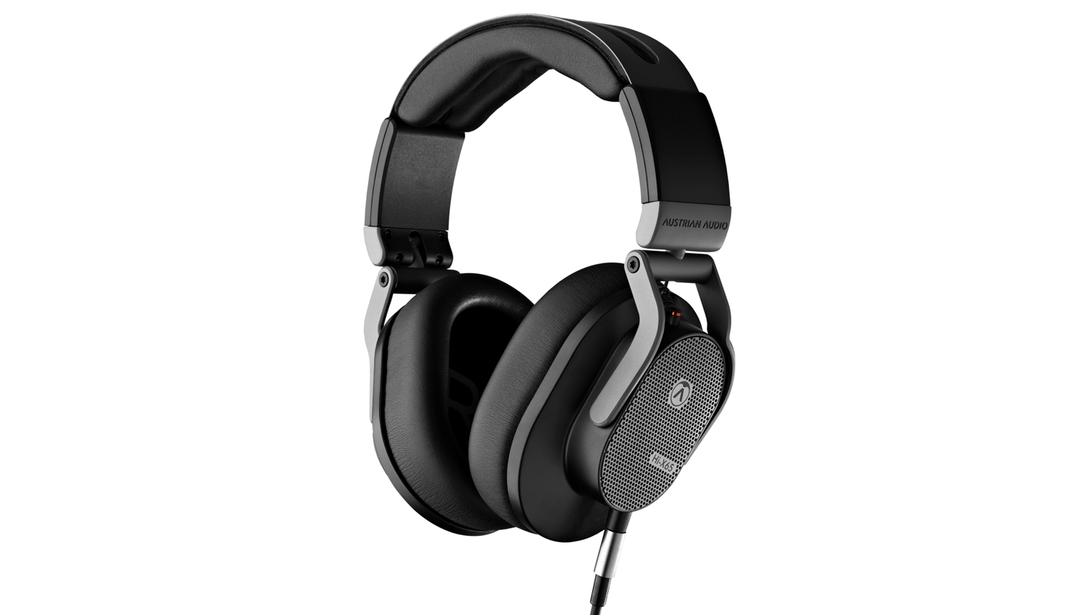

Vienna, Austria, June 6, 2024 — Top-quality headphones and microphone manufacturer Austrian Audio is offering promotions on some of the company’s best-selling audio gear now through August 31, 2024.

During this time, any purchase of Austrian Audio’s Hi-X65 or Hi-X60 headphones will come with a complimentary HXHC case, valued at €29.00 RRP (£25.99 RRP, $35.00 MAP). The HXHC case is designed specifically to fit these hand-assembled Hi-X headphone models, keeping them protected when traveling or otherwise not in use.

The company is also offering a free lavalier microphone with any purchase of their latest portable recording system: MiCreator Studio. The convenient, portable MiCreator Y-Lav, valued at €49.00 RRP (£49.00 RRP, $49.00 MAP), pairs seamlessly with the MiCreator Studio unit, making it easy to expand the system’s recording possibilities.

Users who wish to take advantage of these special offers and save on professional-grade audio gear can find an authorised Austrian Audio dealer here.

About Austrian Audio’s Hi-X65 & Hi-X60 Headphones
Designed, engineered, and manufactured by Austrian Audio’s small team in Vienna, the company’s Hi-X headphone models offer precision, comfort, and reliability for any active listener.

Ideal for mixing and mastering, the Hi-X65 open-back over-hear headphones are made for critical audio production work, highlighting every nuance of a track with crystal-clear sound. The Hi-X60 closed-back over-ear headphones are equally perfect for studio use and louder environments, like front-of-house applications.

Both models include up to five years of warranty coverage from the date of purchase.

About Austrian Audio’s MiCreator Studio & Y-Lav Recording System
Austrian Audio’s newest mic offering, MiCreator Studio, is both a flexible plug-and-play microphone and a multifaceted audio production tool. Designed for recording sound in almost any location, this compact unit is valuable for musicians, content creators, journalists, podcast hosts, and anyone looking to capture high-quality audio on the go.

To add even more flexibility and expand MiCreator Studio’s potential, Austrian Audio’s MiCreator Y-Lav makes it possible for users to record two audio sources simultaneously with latency-free monitoring.

About Austrian Audio
Austrian Audio opened its doors in 2017 following the closure of the AKG offices in Vienna and set out to create something new, challenging, and respectful to its heritage. The new company started with a core team of previous AKG personnel from management, acoustics, electronics, test and measurement, mechanical design, RF/wireless, and software/firmware, bringing 350 years of cumulative engineering experience to the new company. For more information, visit austrian.audio.

